Electronics Cooling System Design

AME 30334

University of Notre Dame

Anya Lindholm and Joe Brady

# Abstract

The development of more powerful computer hardware has made it increasingly important for thermal-mechanical engineers to design more efficient cooling systems to dissipate heat from Central Processing Units (CPUs). In this study, two heat sinks were designed to achieve a minimum cooling heat flux of 1 W/cm​2​ and 100 W/cm​2​, respectively. The dimension of the CPUs were defined parameters of 4 cm by 4 cm with an allowable operating temperature of 90​o​C. To attain the first desired cooling heat flux, a pin-fin heat sink was chosen with the pins arranged in a line and cooled by room temperature air in free convection. The length, diameter, and material of the pin-fins were varied in order to observe the effect of each parameter on the heat flux. The optimal results were produced by aluminum pins-fins 0.775 cm​ ​in length and2 0.875 cm​ ​in diameter. These parameters yielded a satisfactory heat flux of 1.0076 W/cm​ ​. The second heat sink was modeled as a liquid cooled cold plate which has embedded copper tubes in order to contain the liquid. The diameter of the embedded tubes and the velocity of the liquid were varied. A cold plate cooled by liquid water flowing at 1.524 m/s2 ​ through embedded tubes​ 0.65 cm in diameter produced a satisfactory heat flux of 100.1 W/cm​ ​.

*Keywords*​: ​*pin-fin heat sink, liquid cooled cold plate, free convection*

# Introduction

Over the last few decades, the computing capabilities and efficiency of computers have increased. The evolution of computer processing units (CPU) and microprocessor chips have played a key role in the major advancements of the computing revolution. As the performance of the processing systems improves and CPUs become more compact, the power dissipation density also increases [1]. Therefore, it has become increasingly necessary to improve the performance of the methods used to cool the processing systems in order to prevent damage and maximize reliability and longevity. The process of cooling a CPU is known as thermal management, and there are several techniques to dissipate excess heat and minimize the losses in the power supply.

The most general designs for thermal management are heat sinks with fins, heat sinks without fins (more commonly described as cold plates), liquid cooled cold plates, and simply forced and free conduction. The selection of the type of cooling method is dependent on the constraints of the design, such as the size, weight, cost, simplicity, etc. The heat sinks which utilize fins have a greater surface area that is in contact with the surrounding medium, therefore creating a faster dissipation of heat. The medium, most frequently air, employed in this technique is sometimes coupled with forced cooling by a gas in order to maximize the dissipation. The use of liquid for thermal management provides different advantages from the use of gas. The liquid cooled cold plate is embedded with tubes in order to create a closed system for the liquid [2].

If a heat sink with fins is deemed to most suitable for a certain system, the structure and arrangement of the fins must then be chosen. The fins can be designed as continuous walls, plate-fin, or as less continuous structures, pin-fin, two designs with great difference in fluid flow and heat transfer. The plate-fin arrangement is simplistic in design and manufacturing, whereas the pin-fin arrangement is more expensive to fabricate. However, the pin-fin arrangement allows for a higher heat coefficient. When the optimization of these two designs were compared, it was concluded that the pin-fin heat sinks proved to be consistently superior to the plate-fin heat sinks as a number of design parameters were varied [3].

Optimizing a pin-fin heat sink entails varying numerous parameters such as the dimensions of the heat sink, the material used for the pins, the speed of the airflow, and the arrangement of the pins. The staggered and inline arrangements of the pins are the two most conventional designs. The staggered arrangement is superior to its conventional partner when there is a low desired heat flux. However, the former has a larger resistance of airflow which causes a decrease in airflow across the entire heat sink and therefore decreasing the thermal efficiency [4]. With simplicity in mind, the inline arrangement is more effective. A study was proposed in which COSMOL Multiphysics software was used to randomly generate and assign positions to the pins. The arrangements created by this method had a 2.84% and 0.63% increase in thermal performance from the two conventional designs [5]. CPUs are becoming increasingly more complex and include a greater number of transistors, therefore driving the demand for better performing cooling systems. Employing innovative techniques to conduct studies with the goal of improving the thermal management of processing systems is crucial as the capacity of computing grows exponentially.

# Results

The objective was to design two thermal management systems, specifically heat sinks, for two CPUs. The parameters of both CPUs were defined to be 4 cm by 4 cm with a maximum

allowable operating temperature of 90o​ ​C. The first heat sink was designed to meet the2​. The model of a flow across a

constraint of producing a minimum cooling heat flux of 1 W/cm​

bank of tubes found in Chapter 7.6 of the textbook [6] was utilized for the design. The intent of this method was to convect surrounding air at room temperature, assumed to be 23o​ ​C, through an array of cylindrical fins in an inline arrangement.

There were a few important assumptions made in the analysis of the heat sink. The air was assumed to have free convection in order to ensure that a minimum air speed was not required. Taking air to be in free convection also eliminated pressure drop as a factor. The pins were taken to be isothermal with a convective fin tip condition. The base temperature of the fins was assumed to be 90o​ ​C due to an isothermal CPU. The Nusselt number, *Nu*​ ​*D*​, was calculated using

Equation 1, where only valid for vertical cylinders which have a Rayleigh number less that 10*Ra*​ ​*L*​​is the Rayleigh number and *Pr*​ ​ is the Prandtl number. This equation is9​ and a uniform

​

surface temperature, *T*​ ​*S*​. The latter requirement was assumed to be reasonable for the heat sink because the length of the fin was small enough that the change in surface temperature was negligible. This assumption was justified in Figure 1 as the temperature only slightly decreases from the base temperature.

(1)

.

6

8

*N*

*u*

*D*

=

0

+

0

.

6

7

0

*R*

*a*

*L*

1

/

4

1

+

(

0

.

4

9

2

/

*P*

*r*

)

[

9

/

1

6

]

4

/

9

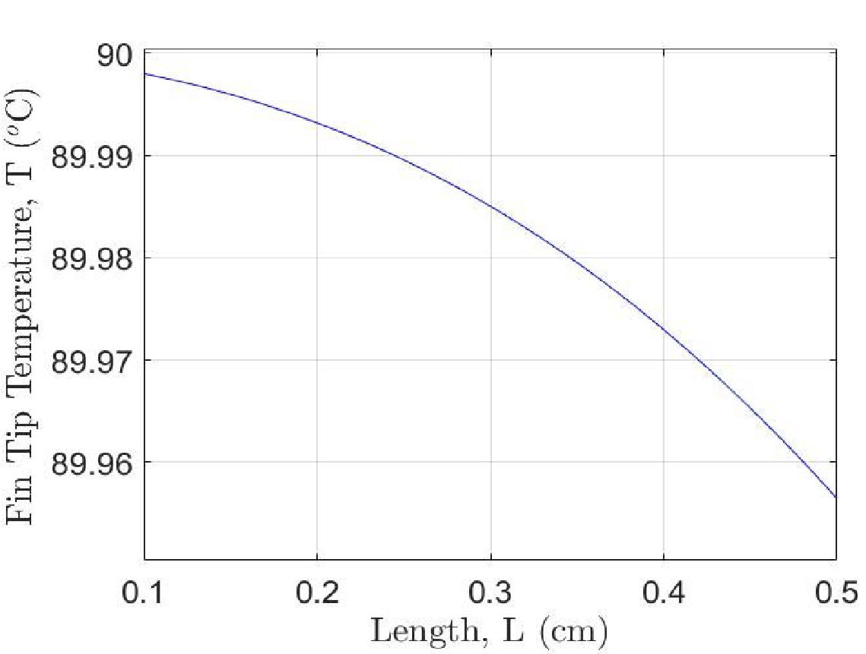

**Figure 1.** The fin tip temperature as a function of the length of the fin.​

Using the convective heat rate tip condition, the fin heat transfer rate, *q*​ ​*f*​, was computed using Equation 2, where *h*​ ​ is the convective heat transfer coefficient, *M*​ ​ is the magnification factor, *m*​ ​ is a calculated constant, *k*​ ​ is the thermal conductivity of material, and *L*​ ​ is the length of the fin.

*qf* = *M scionshh*((*mmLL*))++((*hh*//*mmkk*))*csoinshh*((*mmLL*)) (2)

Initially, the length, radius, and material of the fins were varied to observe the relationship of each varied parameter with the heat flux. The materials investigated were glass, diamond, copper, and aluminum. The heat flux was plotted as a function of these three varied parameters for each material shown below in Figure 2. It was observed that glass and diamond had better performance that the other materials tested, but were eliminated due to feasibility, simplicity, and cost. Although copper was found to produce a slightly better heat flux than aluminum, the latter material was chosen due to practicality and cost.

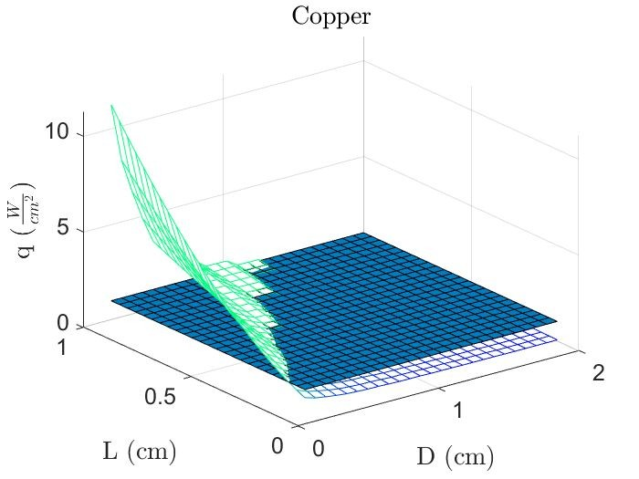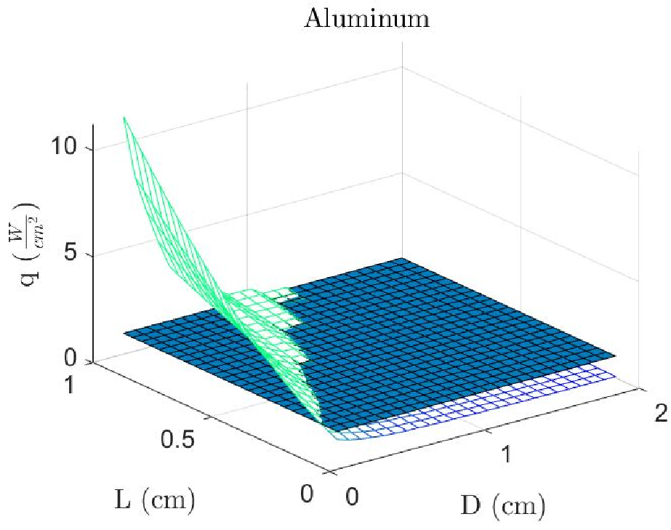

(a) (b)

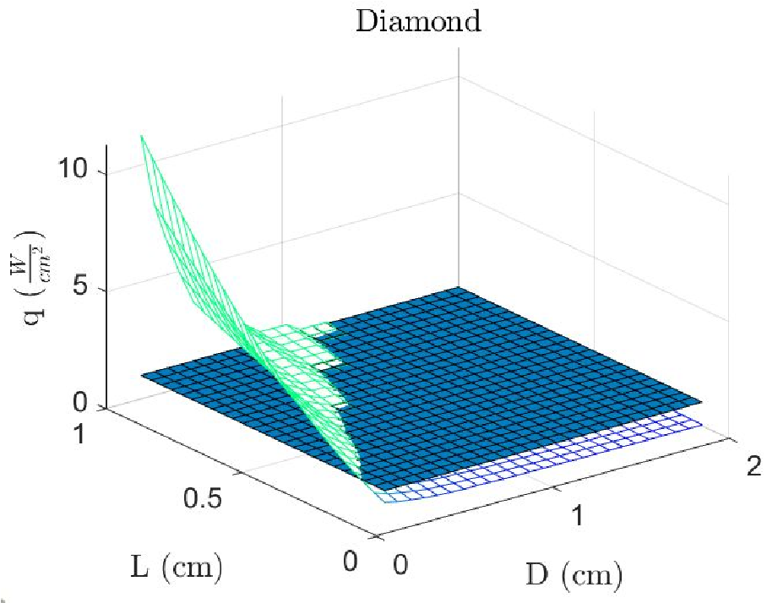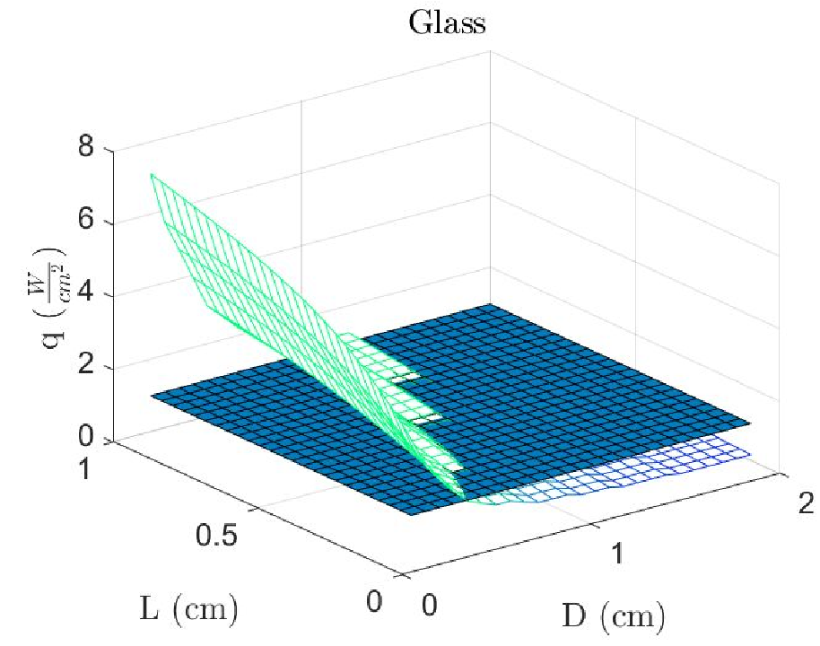

(c) (d)

**Figure 2.**materials tested. The dark blue plane shows the desired heat flux of 1 W/cm​ The heat flux as a function of both the length and diameter of the fins for the four2​ ​.

It was observed from the figures that the points at which the green plane intersects the blue plane were values of the length and diameter that produced a heat flux of 1 W/cm​2​. These data points produced for the aluminum were investigated further with considerations of which values would yield the most effective system. If the radius was too large, the data point was eliminated because less fins would be able to fit on the CPU, creating a less efficient system. Data points with a small radius and length were eliminated because although many pin fins would be fit the constraints of the CPU, the design would be more expensive to manufacture. Therefore, the designed was optimized with a diameter of 0.875 cm and a length of 0.775 cm, allowing 4 rows of 4 pins to fit on the CPU. These parameters produced a heat flux of 1.0076 W/cm​2​, a satisfactory value for the desired performance of the heat sink. The schematic of this design was detailed in Figure 3.

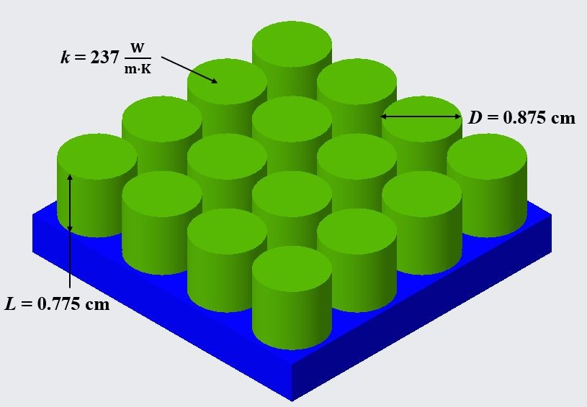

**Figure 3.** The schematic of the first heat sink design composed of cylindrical pins (green)​ aligned in four rows of four pins placed on the surface of the CPU (blue). The length, diameter, and thermal conductivity of the pin-fins are detailed.

The values for the optimal design were detailed in Table 1.

**Table 1.** ​The optimal design parameters for the first heat sink and the heat flux produced.

|  |  |  |  |  |
| --- | --- | --- | --- | --- |
| **Fin**  **Arrangement** | **Fin Material** | **Fin Diameter (cm)** | **Fin Length (cm)** | **Heat**  **Flux (W/cm**​**2**​**)** |
| Inline | Aluminum | 0.875 | 0.775 | 1.0076 |

The second heat sink was modeled as a liquid cooled cold plate to reach the required heat flux of 100 W/cm​2​. The liquid was chosen to be water as it can reach a much higher convective heat transfer coefficient than free convective air or impelled convective air. Moreover, and internal the flat cold plate cooling system allows the microchip to be more compact. A schematic of the design is shown in figure 7. The model of a flow in a circular pipe found in Chapter 8.5 of the textbook [6] was utilized for this design. It was important to note that for this cold plate analysis, the temperature of the cold plate surrounding the pipe was assumed to be uniform. This was a reasonable assumption, as the cold plate had a small volume and, being made of aluminum, has a high thermal conductivity.

When considering the design of the channel, two main factors were considered: the diameter of the pipe in the cold plate and the number of passes. The number of passes increased the effective length of the pipe and therefore the heat flux through the cold plate, but required more pumping power. Moreover, the diameter and number of passes of the pipe needed to be such that the piping fits within the chip dimensions and flow remains turbulent. The Nusselt number of a fluid in internal flow was calculated using Equation 3, where *Re* ​ ​is the Reynolds number and *f* ​ ​is the friction factor.

*Nu* = 3.66 *if*​ ​ Re < 2,300

*Nu* = (*f*/8)(*Re* −1 1/2000)2*P*/3*r*  *if*​ ​ 2,300 < Re < 10,000

1 + 12.7(*f*/8) (*Pr* −1) (3)

*Nu* = 0.023*Re*4/5*Pr*0.4 *if*​ ​ Re > 10,000

It was observed that the heat flux is proportional to the Nusselt number. Moreover, the Nusselt number becomes significantly higher at turbulent conditions, *Re*​ ​ >10, 000. The Reynolds number was computed using Equation 4, where ṁ is the mass flow rate, *D*​ ​ is the diameter of the pipe, and μis the dynamic viscosity.

# *Re* = *D*4πṁμ (4)

The Reynolds number is proportional to the diameter, making it critical that the diameter of the hole remain small enough to maintain turbulent flow. Increasing the pipe diameter also decreased the pressure drop across the pipe and therefore the motor power required. The pressure drop across a pipe was calculated by Equation 5, whereρis the density of the fluid and *u* ​ ​is the velocity of the fluid.

# Δ*p* = *f* ρ2*uDm*2 *L* (5)

It was optimal to increase the diameter of the pipe so long as *L/D* ​ ​remained above 10, at which point fully developed flow ends and the heat flux through the pipe decreases significantly. Figure 4 details the effects of pipe diameter on heat flux and pressure drop through the pipe.

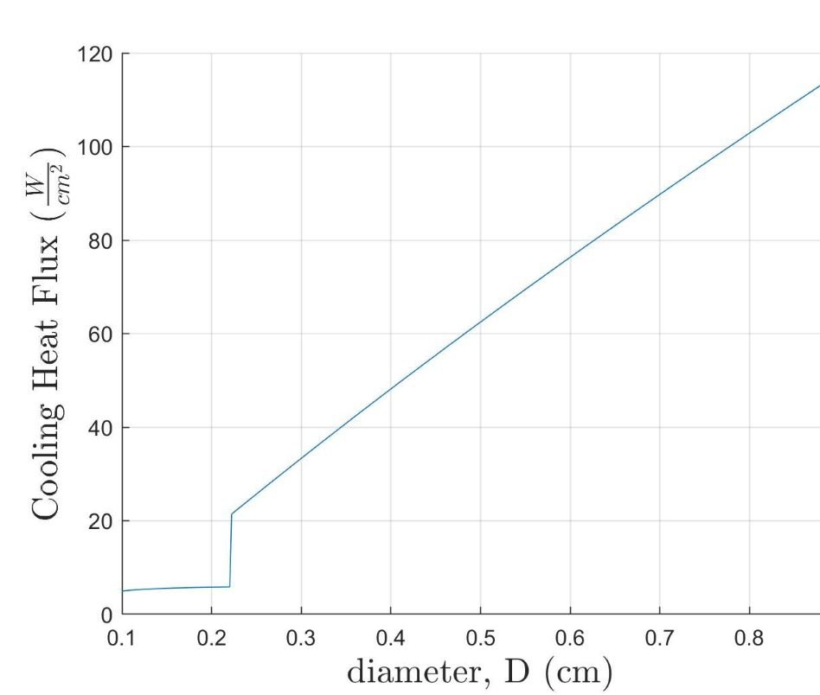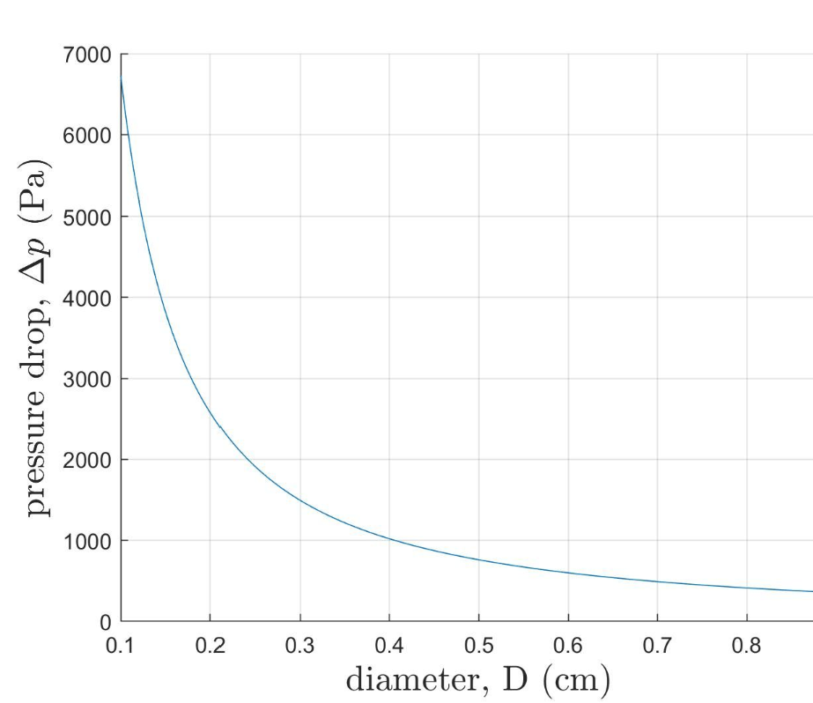

(a) (b)

​**Figure 4.** ​The heat flux as a function of pipe diameter (a) and the pressure drop as a function of pipe diameter (b) for the cold plate design.

Fluid velocity also affects the heat flux and pressure drop of the cooling system. High fluid velocity ensures that the flow remains turbulent, which is necessary to reach the desired heat flux. Low fluid velocity reduces the pressure drop across the pipe. It was found that turbulent conditions are reached at fairly low velocities, so the fluid velocity was kept relatively low to minimize pressure drop through the pipe. Figure 5 shows the effects of fluid velocity on heat flux and pressure drop.

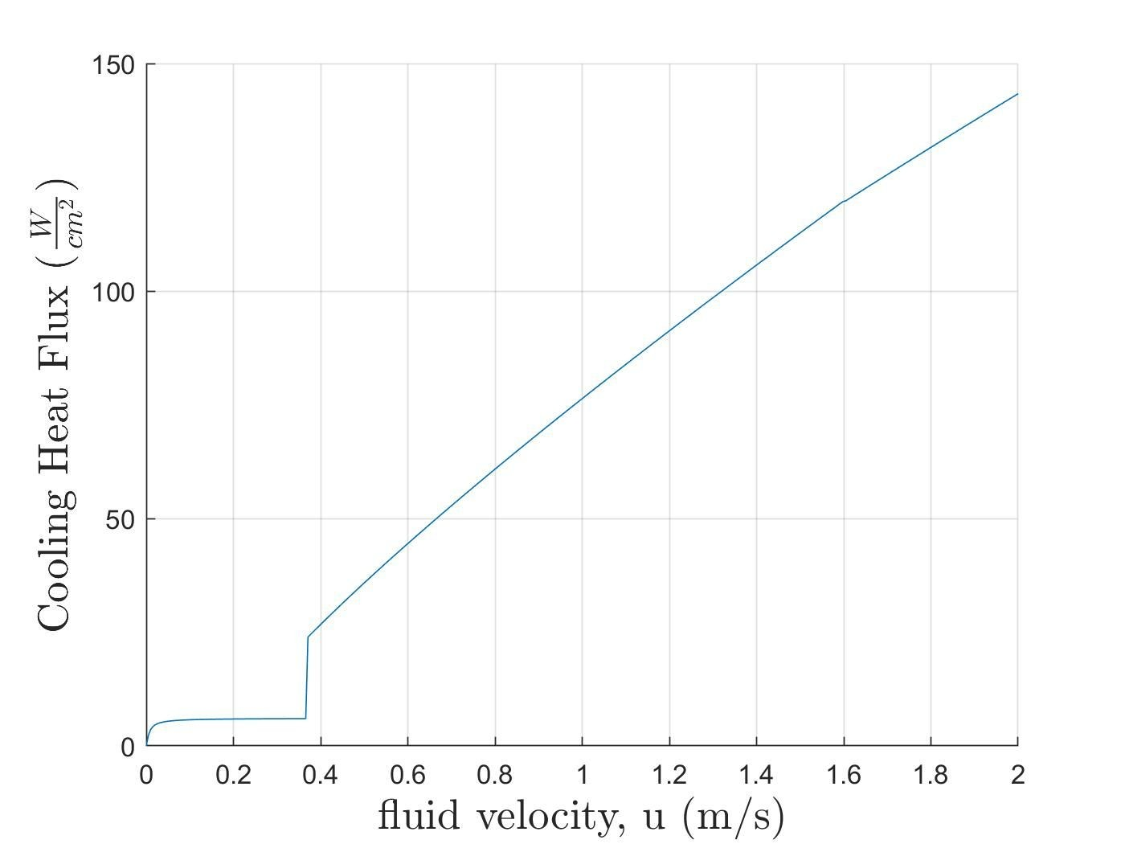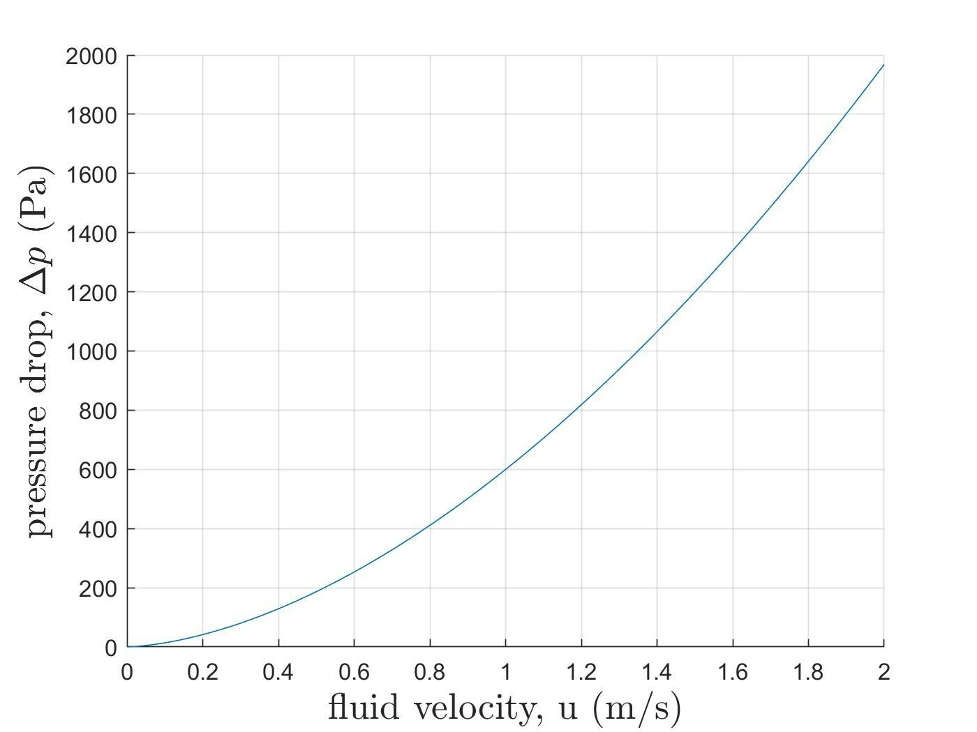

(a) (b)

**Figure 5.**​ The heat flux as a function of the fluid velocity (a) and the pressure drop as a function of the fluid velocity (b) for the cold plate design.

In summary, optimization of the system requires a pipe with a larger diameter, a length greater than 10​*D*​, and a relatively low velocity. Theoretically, the thickness and material of the pipe should be considered. However, with copper as the chosen material, the thickness of the pipe has a negligible effect on the heat flux of the cooling system. Copper was chosen for its high thermal conductivity, low cost, and because it is commonly used in cold plate designs. The choice cooling fluid was also considered. Water was chosen for the design because it is cheap, unreactive, and has a high thermal conductivity. Lastly, dimensional constraints were considered. Increasing the diameter of the pipe limited the number of passes possible on the cold plate (the number of passes increases the effective length of the pipe, ​*L*​). The cold plate also needed to have enough passes of the pipe to effectively conduct head away from the entire section of the chip and ensure relatively uniform cooling. To test for optimal conditions, three settings were used: a large ​*D* ​and a small number of passes, a small ​*D* ​and a large number of passes, and a middle setting. The results were displayed in Figure 6.

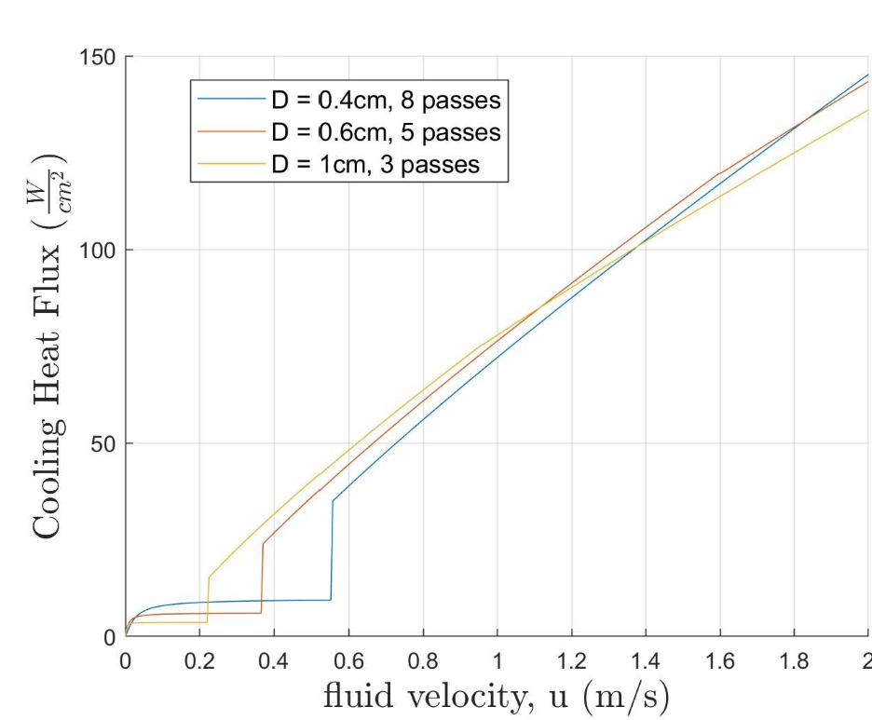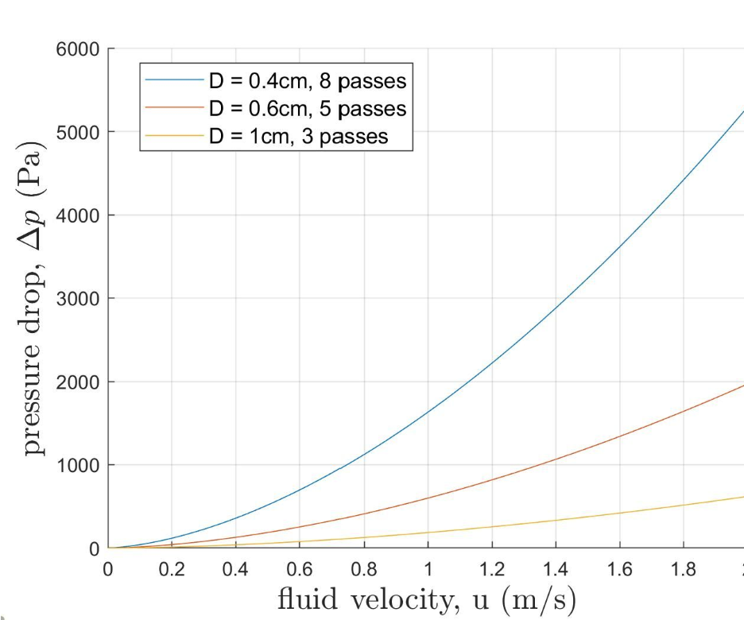

(a) (b)

**Figure 6.** ​The heat flux as a function of the fluid velocity (a) and the pressure drop as a function of the fluid velocity (b) for three pipe parameter arrays.

It was observed from the figure that increasing the diameter and decreasing the number of passes of the pipe are confounding, and create very little change in heat flux after transition to turbulent flow. However, increasing the diameter drastically reduces the pressure drop through the pipe. For the optimal configuration, four passes was chosen. To limit the pressure drop along the pipe while ensuring enough space between passes, a diameter of 0.65 cm was chosen. The design achieved the desired heat flux of 100 W/cm​2​. A schematic of the optimal design is depicted by Figure 7.

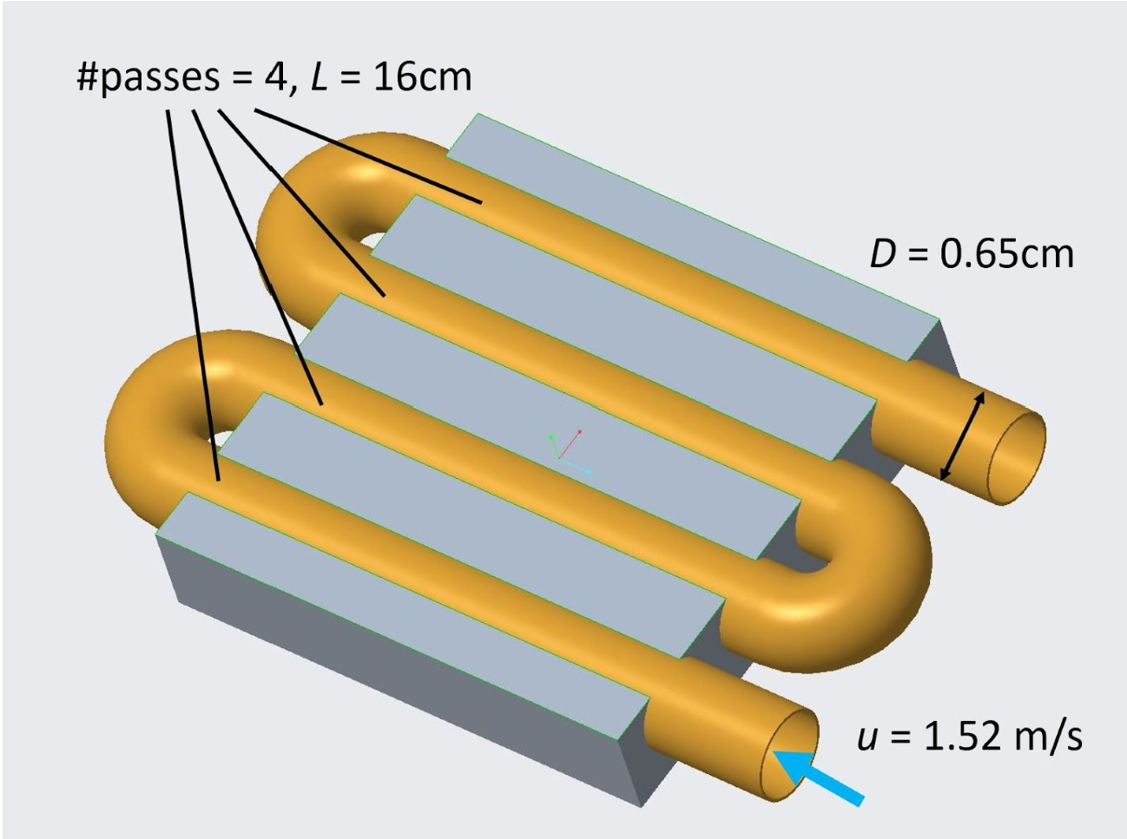

**Figure 7.** ​The schematic of the optimal cold plate design composed of a copper piping (orange) passing through an aluminum plate (grey), which would sit on top of the CPU. The effective length, number of passes and diameter of the pipe, as well as the velocity of the fluid into the pipe, are depicted.

The parameters for the optimal cold plate cooling system design were detailed in Table 2.

**Table 2.** ​Parameters for the optimally designed cold plate cooling system

|  |  |  |  |  |  |
| --- | --- | --- | --- | --- | --- |
| **Pipe**  **Diameter**  **(cm)** | **# passes**  **(Effective**  **Length (cm))** | **Fluid Speed (m/s)** | **Heat Flux (W/cm**​**2**​ **)** | **Pressure Drop (Pa)** | **Required**  **Motor**  **Power (mW)** |
| 0.65 | 4 (16) | 1.524 | 100.1 | 889.6 | 45.35 |

If cost were not a factor, we would consider implementing a coil spring, helical ribs, or longitudinal fins in the interior of the pipe to enhance heat transfer. All of these additional parameters would increase the roughness of the pipe and cause the fluid to transition to turbulent flow at lower fluid velocity. However, patterns in such a small diameter pipe would require high precision and would likely be costly to manufacture. Moreover, the water already transitions to turbulent flow at fairly low speeds, so any improvements to the system from these design additions would likely be minimal and not worth the cost.

## Conclusion

The pin fin design was able to reach the required heat flux through free convection. This design is preferred as it requires no motor, so the design is more compact, more resilient, and requires no power. Other studies have compared inline pin fin arrangements to random staggered arrangements, and found that random staggered arrangements may perform better [4]. Further experimentation should be done to find optimal pin arrangement configurations.

The cold plate cooling system also achieved the required heat flux. Using water as a coolant significantly improves the heat flux compared to the fin arrangement and air and draws much more heat away from the computer chip. From experimentation, large pipe diameters and smaller velocities perform the best in both maximizing heat flux and minimizing pressure drop. In the future, the use of microchannels etched into the chip should be explored. Microchannels can be placed closer to the heat source for more efficient cooling. Drawbacks of microchannels include a need of large fluid velocities, significant pump power, and precise, costly machining. Future studies should explore how to overcome these drawbacks to achieve better cooling system performance.

## References

1. ​R. Mahajan, Chiu, C.P., and Chrysler, G., “Cooling a Microprocessor Chip,”​ *Proceedings of IEE*​E, vol. 94, pp. 1476-1486, 2006. https://ieeexplore.ieee.org/abstract/document/1705137/citations#citations
2. ​“Overview of Cooling Methods for AC-DC and DC-DC Power Supplies,” *Aegis Power*​  *Systems*​. 2015.

https://www.aegispower.com/index.php/2015-01-15-19-35-10/192-cooling-methods-for-powersupplies

1. ​Kim, Bae, Kim, “Comparison of thermal performances of plate-fin and pin-fin heat sinks subject to an impinging flow”, ​*2008 11th Intersociety Conference on Thermal and Thermomechanical Phenomena in Electronix Systems*​, 2008.

https://ieeexplore.ieee.org/abstract/document/4544292

1. Y. Yang, H. Peng, “Numerical study of pin-fin heat sink with un-uniform fin height design”, *International Journal of Heat and Mass Transfer*​, 51 (2008), pp. 4788-4796.

https://www.sciencedirect.com/science/article/pii/S001793100800121X

1. K.A.M. Annuar, F.S. Ismail, “Optimal pin fin arrangement of heat sink design and thermal analysis for central processing unit”, ​*2014 5th International Conference on Intelligent and*

*Advanced Systems (ICIAS)*​, 2014. https://ieeexplore.ieee.org/document/6869537

1. ​Incropera, Frank P, and David P. DeWitt. ​*Fundamentals of Heat and Mass Transfer*​. New York: J. Wiley, 2002. Print.

## Appendix A - MATLAB Script for Cold Plate Design

%% Start

clear; clc; clf;

%% Parameters

% System Parameters

k_material = [401, 237, 2200, 1.05];

Material = {'Copper', 'Aluminum', 'Diamond', 'Glass'};

for Mat = 1:length(k_material)

% System Parameters

T_b = 90; % max allowable chip (base) temp

T_inf = 23; % room temperature air

Transverse = .04; % transverse length of chip Longitudal = .04; % longitudal length of chip

% Chose .1cm min arbitrarily, 2cm max radius (fills chip)

R = linspace(.001, .01, 25);

L = linspace(.001, .01, 25);

% Initialize optimization, goal: find best radius for fins on the chip surface q_Opt = 0;

n = 1;

for j = 1:length(L) for i = 1:length(R)

%% Strategy

% Find the array geometry

% Find the Nusselt number for the array

% Find the average heat transfer coefficient, h

% Find the heat transfer of a fin surface

% Find the toatal heat transfer of the sink

%% Find the array geometry

N_l = Longitudal/(R(i)+.001); % how many pins of this diameter will fit?

N_l = round(N_l, 0); % only whole pins

N_t = Transverse/(R(i)+.001); % repeat for other direction

N_t = round(N_t, 0); % only whole pins

%% Find the Nusselt number for the array

% Use air to find h rho = 1.1614; % density of working fluid (air) c_p = 1.007; % heat capacitance of working fluid (air) Pr = .703; % Prandtl of working fluid (air) k_air = 26.3*(10^-3); % heat conductance of working fluid (air) nu = 15.8*(10^-6); % kinematic viscosity of working fluid (air) g = 9.81; % m/s^2 gravity constant

T_f = (T_b+T_inf)/2;

Beta = 1/T_f; % Bouancy Factor

Gr = (g*Beta*(T_b-T_inf)*(L(j)^3))/(nu^2); % Grashoff number Ra = Gr*Pr; % Rayleigh number

Nu = .68+((.67*(Ra^(1/4)))/((1+((.492/Pr)^(9/16)))^(4/9))); % calculation of nusselt number

%% Find h

h = (Nu*k_air)/(2*R(i)); % finding average heat convection coefficient for fins

%% Find the heat transfer fo the fin surface

% Vary material k_use = k_material(Mat);

% Given Temp difference for ambient air (23) from the chip surface (90) Theta_b = T_b-T_inf;

P = 2*pi*R(i); % Perimeter of fin

A_c = pi*R(i)^2; % Cross sectional area of fin m = sqrt((h*P)/(k_use*A_c)); % fin parameter m

M = sqrt(h*P*k_use*A_c)*Theta_b; % magnification factor q_f =

(M*sinh(m*L(j))+(h/(m*k_use))*cosh(m*L(j)))/(cosh(m*L(j))+(h/(m*k_use))*sinh(m*L(j)))/10000; % heat transfer of a single fin

%% Find the total heat transfer and report optimum q_b = h*Theta_b/10000; % heat transfer of ends and gaps q(j, i) = q_f*N_l*N_t/(.04)^2 + q_b; % heat transfer of all fins and ends

D_cm = 2*R*100; % convert radius to cm and multiply to get diameter L_cm = L*100; % convert length to cm

if q(j, i)>1 && q(j, i)<1.01 disp(['The diameter is : ', num2str(D_cm(i)), 'cm']) disp(['The length is : ', num2str(L_cm(j)), 'cm'])

disp(['The heat transfer rate [W/cm^2] is : ', num2str(q(j, i))]) disp(['The material is : ', Material(Mat)]') disp('')

Bestr(n) = R(i); Bestl(n) = L(j); n = n+1; end end

end

z = ones(length(R));

figure(Mat) % Plot results mesh(D_cm, L_cm, q) colormap(spring) hold on surfl(D_cm, L_cm, z) colormap(winter) xlabel('D (cm)', 'interpreter', 'Latex') ylabel('L (cm)', 'interpreter', 'Latex') zlabel('q ($\frac{W}{cm^2}$)', 'interpreter', 'Latex')

set(gca,'fontsize', 15)

end

%% Plots figure(1)

title('Copper', 'interpreter', 'Latex') figure(2)

title('Aluminum', 'interpreter', 'Latex') figure(3)

title('Diamond', 'interpreter', 'Latex') figure(4)

title('Glass', 'interpreter', 'Latex')

## Appendix B - MATLAB Script for Cold Plate Design

%% Start

clear; clc; close all;

%% Set Parameters N = 400; vel= linspace(0, 2, N); %[m/s] rho = 997; D = [0.0065];%[0.008];

L = [0.16]; %[m]

%D = linspace(L/50, L/5, 200);

%D = 0.006;

Pr = 6.62;

Pthic = 0.0005; kWater = 0.606; %[W/mK] mu = 959e-6; %[N*s/m^2] kCopper = 401; %[W/mK]

Ts = 90; %[Celsius] Tmi = 20; %[Celsius]

cp = 4181;

%% Calculate flux and pressure drop

for d = 1:length(D) for i = 1:length(vel) %for l = 1:length(L) l = d;

%find the reynolds number A = pi.*(D(d)/2).^2; %[m^2] mdot = rho.*vel(i).*A; %[m] Re = (4.*mdot)./(D(d).*pi.*mu); xh = 0.05*Re*D(d); xth = Pr*xh;

% see if flow is fully developed

if L(l)/D(d) >= 10 || xth < L(l)

% Determine Nu based on Reynolds Number if Re < 2300 Nu = 3.66; end if Re > 10000

Nu = 0.023*(Re^(0.8))*Pr^(0.4);

cond = 'turbulent'; end

if Re >= 2300 && Re <= 10000 f = (0.79*log(Re)-1.64).^(-2);

Nu = ((f/8).*(Re-1000)*Pr) ./ (1 + 12.7*((f/8).^0.5)*(Pr^(2/3)-1)); cond = 'in between';

end else

Nu = 3.66 + 0.0668*(D(d)/L(l))*Re*Pr/(1+0.04*((D(d)/L(l)*Re*Pr)^(2/3))); cond = 'developing';

end

%find h and from there h = Nu.*kWater./D(d); %W/m^2 K

Rtot = log(1+Pthic)/(2*pi*L(l)*kCopper)+1/(h*pi*D(d)*L(l)); K/W Tmo = Ts - exp(-1./(mdot.*cp.*Rtot))*(Ts-Tmi); deltaT = ((Ts-Tmo) - (Ts-Tmi)) ./ log((Ts-Tmo) ./ (Ts-Tmi)); %K q(l, i) = deltaT/(Rtot)/16; %W/m2 f = (0.79*log(Re)-1.64).^(-2); deltaP(l, i) = f.*rho.*vel(i).^2 ./ (2.*D(d))*L(l); Ppump(l, i) = deltaP(l, i)*mdot/rho; %W end end

%end

%% plot results figure(1) hold on plot(vel, q(1,:)) % plot(vel, q(2,:))

% plot(vel, q(3,:)) % plot(vel, q(4,:))

xlabel('fluid velocity, u (m/s)', 'interpreter', 'latex') ylabel('Cooling Heat Flux ($\frac{W}{cm^2}$)', 'interpreter', 'latex') %legend('D = 0.4cm, 8 passes', 'D = 0.6cm, 5 passes', 'D = 1cm, 3 passes') grid on hold off

figure(2) hold on

plot(vel, deltaP(1,:)) % plot(vel, deltaP(2,:))

% plot(vel, deltaP(3,:))

% plot(vel, deltaP(4,:)) xlabel('fluid velocity, u (m/s)', 'interpreter', 'latex') ylabel('pressure drop, $\Delta p$ (Pa)', 'interpreter', 'latex')

%legend('D = 0.4cm, 8 passes', 'D = 0.6cm, 5 passes', 'D = 1cm, 3 passes') grid on hold off

figure(3) plot(vel, Ppump(1,:)) % plot(vel, deltaP(2,:))

% plot(vel, deltaP(3,:)) % plot(vel, deltaP(4,:)) xlabel('fluid velocity, u (m/s)', 'interpreter', 'latex') ylabel('pressure drop, $\Delta p$ (Pa)', 'interpreter', 'latex')

%legend('D = 0.4cm, 8 passes', 'D = 0.6cm, 5 passes', 'D = 1cm, 3 passes') grid on

hold off